**The Slave Port**

# Aki Yoshida JA1NLX and Rick Ellison N2AMG

## 1.0 GENERAL

The Slave Port was originally implemented in Logger32 version 3.50.358.

a)The Slave Port synchronizes a slave receiver/transceiver (of any type) with the main radio frequency and mode and,

b) if “Enable polling of the slave receiver/transceiver....” option is checked then main radio follow slave radio frequency and mode.

## 2.0 SLAVE PORT SETUP

To configure the Slave Port, from the Logger32 Setup menu, select the Radio | Slave port configuration menu items.

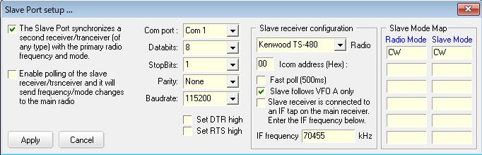

New TSP_1

If your transceiver reports both VFO A and VFO B frequency/mode in real time, you may uncheck “Slave follows VFO A” option.

If you prefer fast polling of slave receiver/transceiver, you may check “Fast poll (500ms)” option. If it is unchecked, polling interva is 1000ms.

Note: “Slave receiver is connected to an IF tap on the main receiver” option

This simply sets the SDR to the IF frequency and does not send any more frequency commands. It also turns off polling of the slave radio.

Depending on the sequence the user starts Logger32 and the SDR, there can be difficulty synchronizing the SDR to the IF frequency. If the user starts Logger32 and opens the Slave Port, then the command to set the slave to the IF frequency is automatically sent. The user then turns on the SDR. It missed the IF frequency command so it just sits there with no eye-candy. The user can force the slave to resync either by closing/opening the slave port, or by executing a new Radio Control Panel macro $slavesync$

The Slave port is opened/closed by right clicking the Radio pane on the Lower Status bar.

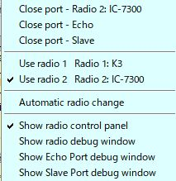

TSP_2

The Slave Port state, open or closed, is shown on the Status bar of the Radio Debug window.

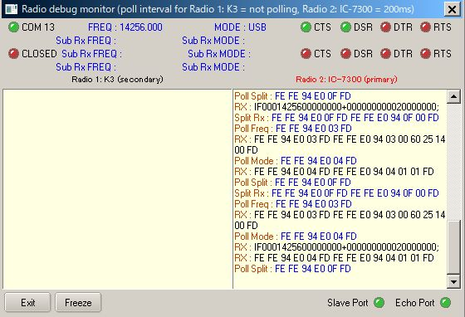

TSP_3

You can see what command is sent to slave radio in Slave Port Debug window.

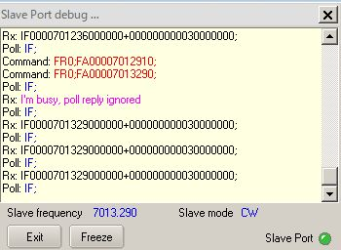

TSP_4